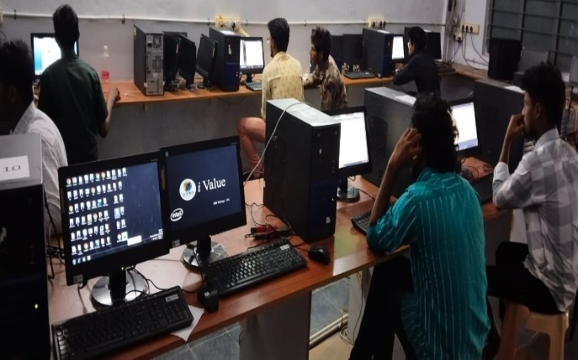**COMPUTER APPLICATIONS – PROFILE**

COMPUTER LAB

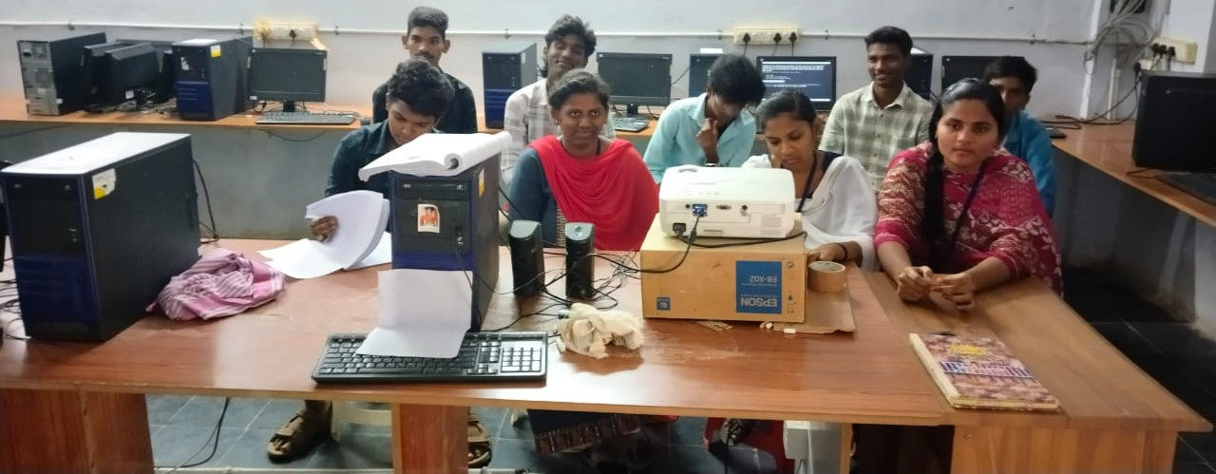

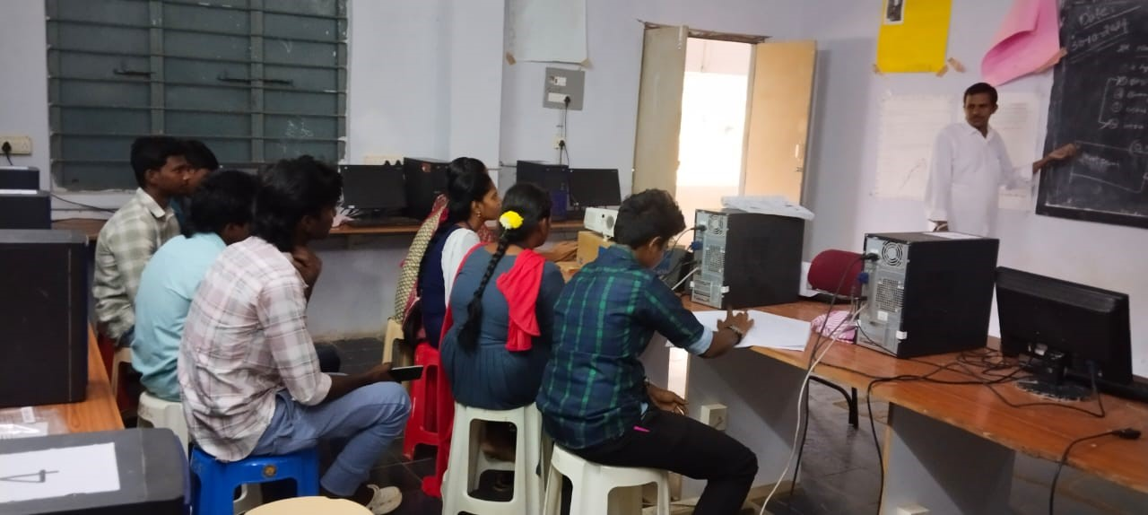

COMPUTER CLASS

COMPUTER CLASS

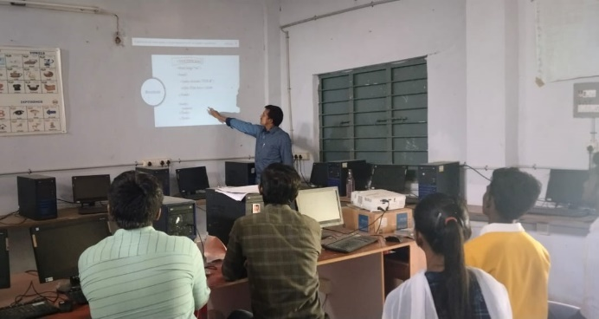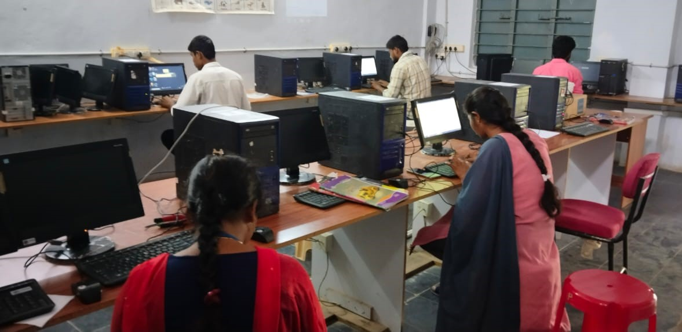

PROJECTOR CLASS

LAB PRACTICE

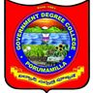 **GOVT DEGREE COLLEGE ,POPRUMAMILLA.**



**KADAPA (DT)-516193, Andhra Pradesh.**

**DEPARTMENT OF PROFILE**

1. **Name of the Department : COMPUTER APPLICATIONS**
2. **Year of Establishment : 2008**
3. **Name of the course Offered : B.Com(CA)**

|  |  |  |
| --- | --- | --- |
| **Programs** | **Courses** | **TYPE** |
| **UG** | **Computer Applications** | **CBCS Semister System** |
| **Career oriented programs** | **ICT** | **B.Sc, B.com, B.A** |

The department of Computer Applications was established in the academic year 2008. B.Com Computer Applications as one of the restructured courses in the college there are several ways to present the canonical core of computing Applications. Over the years we have developed a distinctive style and method that bridges the theory-practice divide while remaining grounded in the core.

We want the education important to our students to be the bases of a lifetime of learning. In the recent fast we had benchmarked our curriculum with select institutions of higher learning and currently we are carefully reviewing the impact of these consequent changes with a view to make our programs even more strong and competitive. We offer a varied study program of Choice Based Credit System (CBCS) that provides students with a wide range of options to choose from. Our passionate and exceptionally skilled lecturers pleased to help our students achieve their full potential. Department library has reference books and textbooks for the beneficiary of the students.

Even though the students are mostly rural background they are very much enthusiastic in attending the classes and other career – oriented programs like JKC. Now The Computer Applications is Following National Education Policy 2020 as B.Com Computer Appliaction as Major with effect from 2023-2024.

**The Student learning enrichment programs:**

*Other method of involving students in learning include the following methods

*Group discussions

*Quiz

*Seminars

*Assignments

*Power Point presentations

*Video lectures and audio lessons i.e Projector

*The strong feedback mechanism perfectly involving students help faculty members to enhance their professionally competency.

**Best practices :**

* Distribution of books by self finance to the poor students .